The Children Need Your Love
January 31st, 2021

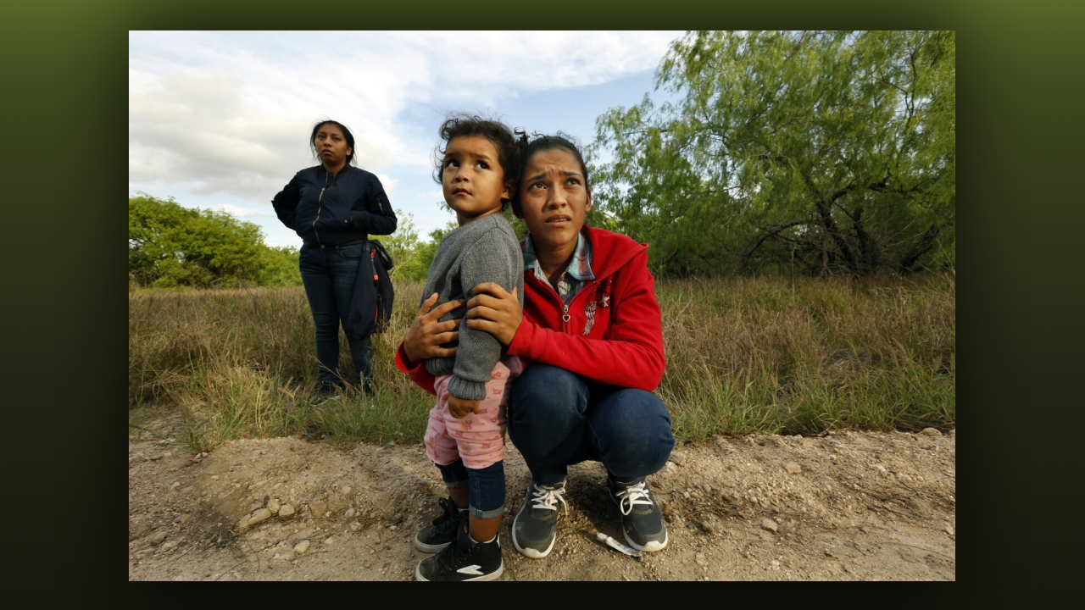
Dear Brothers and Sisters, we have been helping support financially a children’s home near the Texas/Mexico border and they have been so thankful for the ability to be able to help pay for medicines and psychological help for some of the children who are in desperate need of healing and love.

There is one child in particular that tugs at our heart strings, her name is Ana, she is 13 years old. She has been experiencing abdominal discomfort as a result of this chronic situation for her, since she was four years old. Ana was brought to the owners of children’s home, Rudy and Anna, from the Mexican government.

They took Ana to a doctor at the Health Department and she recently had an ultrasound and extensive blood analysis. The ultrasound showed a tiny cyst on her right ovary and some inflammation in her colon. She was put on two medications and a special diet. Little Ana has psychological counseling once a week with a woman psychologist due to her traumatic past to help heal her emotionally and mentally.

Rudy and Anna the owners of the children’s home worked their whole lives, saved up funds, had 401K’s and then upon retirement, the Lord told them to liquidate all their assets and set up a children’s home near the Texas/Mexico border because of the tremendous need to house and heal children who had lost their parents or had been separated from them. And this courageous couple did just that. They liquidated their 401K’s, took their savings and have been operating the children’s home ever since.

Anna and Rudy are true servants of God. Instead of retiring comfortably after working so hard all their lives in the corporate world, they chose wisely and are working solely for the Lord. Living for Him through their generous love and care for His little ones.

What Rudy, Anna and these children truly need right now is people to help them, to love and care for these precious innocents. Individuals who are willing to be “boots on the ground” and give of themselves to help others.

Dear Heartdwellers, if any of you feel led to help these servants of God and can speak Spanish and English or the language of love, please reach out to us at email address lightofthewoods@taosnet.com Attention: Mother Elisabeth, and we can offer you further details on location and contact information.

For those of you who desire to help the children’s home financially, their PayPal email information is in the written text below.

PayPal – payitforward316@gmail.com Rudy Gorena

We love you all and are praying for you! God bless you dear ones.

